1 | P a g e


StaffBank Interface User Guide

Version: 2.38

SB Version: 2309.01.00.03

State: Final Release

Issue Date: 23/Jan/2024
2 | P a g e

Contents

Caller Authentication and Authorisation 4

Audit on changes made through the interface 6

Create Holiday Booking 7

Holiday Booking mapping to database Fields 8

Direct Mapping 8

Indirect Mapping 8

Fixed Values 8

Passing optional datetime values 9

Errors Codes 10

Note IDs / Notification IDs used in GetNotifications Web Method - 14

Shift Status Enum used in ShiftRequest Web Method – 16

Encryption of user name and password 16

Setup 16

Encryption Code 17

Code Snippets 18

Creation of the Service Reference in Visual Studio.NET 18

VB.NET Code Snippets 20

AuthenticateCaller 20

AuthenticateFlexibleWorker 21

CancelHolidayBooking 22

CreateHolidayBooking 23

ExactHolidayBooking 24

GetFlexibleWorkerDetails 25

SearchFlexibleWorker 26

SearchHolidayBooking 27

UpdateHolidayBooking 28

C# Code Snippets 29

AuthenticateCaller 29

AuthenticateFlexibleWorker 30

CancelHolidayBooking 31

3 | P a g e

CreateHolidayBooking 32

ExactHolidayBooking 33

GetFlexibleWorkerDetails 34

SearchFlexibleWorker 35

SearchHolidayBooking 36

UpdateHolidayBooking 37

StaffBank User Guide Changes 38

StaffBank Reference Changes 39

4 | P a g e

Caller Authentication and Authorisation

The StaffBank client will now offer the functionality to create new callers to the StaffBank Interface. The screen to create the new callers will be similar to the screen shot shown below.
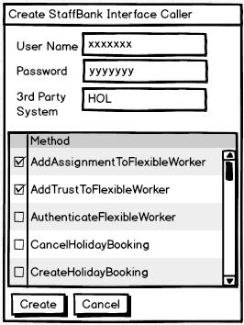

This allows NHSP to create a user name and password combination for each caller and also identify the 3rd party system from which this call originates.

NHSP can also control the methods in the interface that can be accessed by this caller.

In the screen shot above the caller has authorisations for the AddAssignmentToFlexibleWorker and AddTrustToFlexibleWorker methods and doesn’t have authorisation for AuthenticateFlexibleWorker.

The StaffBank Interface is a WCF service and exposes methods as shown below.
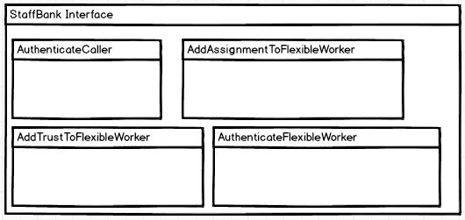
5 | P a g e

The first call that the caller needs to make is to the AuthenticateCaller method of the StaffBank Interface as shown below.
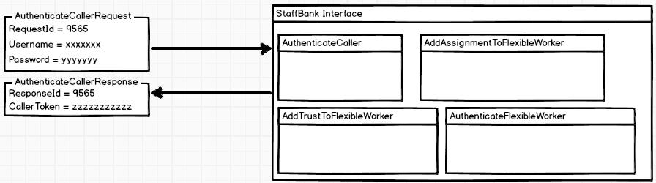

The caller passes the Username and password allocated to them by NHSP to the AuthenticateCaller method and if successful receives a CallerToken on the AuthenticateCallerResponse.

All methods, with the exception of AuthenticateCaller, require CallerToken to be provided on the request.

The caller calls the method AddTrustToFlexibleWorker as shown below. The CallerToken that was received by the user on the AuthenticateCaller response is now sent along with the AddTrustToFlexibleWorkerRequest.
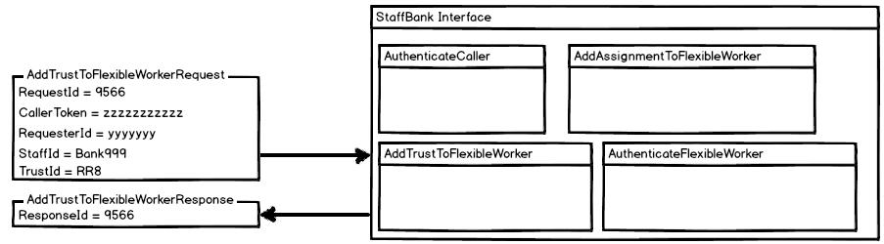

As this caller is authorised for this method the request succeeds and a valid response is sent back.

If the same caller now attempts to call the AuthenticateFlexibleWorker method, an error response is sent back as the caller is not authorised to access this method.
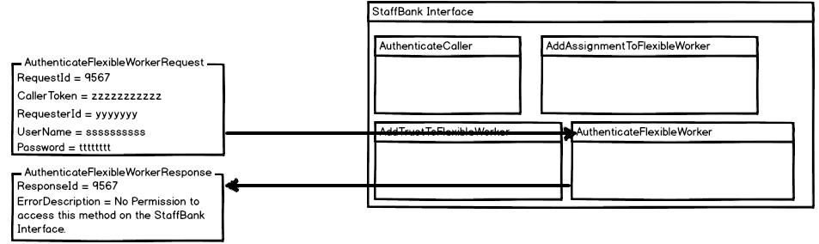
6 | P a g e

Audit on changes made through the interface

The value passed on the RequesterId field of the request is used to audit any changes made through the StaffBank Interface.

When the caller add a trust to the flexible worker making a call as shown above, the changes will be audited in StaffBank under yyyyyyy [HOL]. Where HOL is the 3rd party system that the calls originated from.

7 | P a g e

Create Holiday Booking
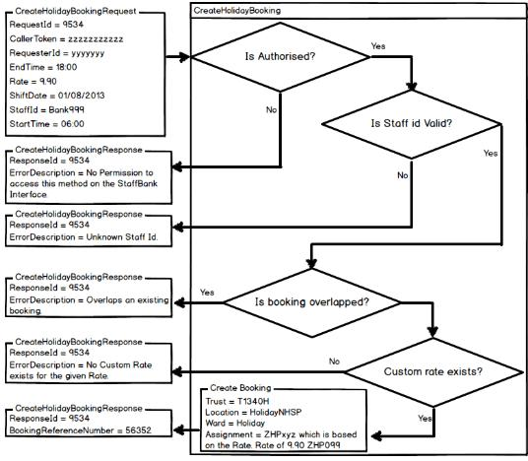

The Create Holiday Booking creates the both the request and booking in the same call.

The request and booking are created at the T1340H Trust, HolidayNHSP location and Holiday ward.

The assignment used is based on the rate that is passed in the request and is computed using this formula
‘ZHP’ + FORMAT( “000”, Rate * 10)

Only rates that that are exact multiples of 10p will be allowed.

The table below gives some examples of the rates and their assignments

Rate | Assignment | ErrorCode | ErrorDescription
5.90 | ZHP059 | 0
5.99 |  | 110 | No Custom Rate exists for the given Rate.
9.20 | ZHP092 | 0
18.50 | ZHP185 | 0
37.56 | ZHP375 | 110 | No Custom Rate exists for the given Rate.

The functionality bypasses the validations of StaffBank and hence will allow the holiday booking to be added even though the FW doesn’t have availability for the Trust or doesn’t have that particular assignment attached to them.

8 | P a g e

Holiday Booking mapping to database Fields

Direct Mapping

Some of the fields in the holiday booking requests / responses map directly to values in the Request / Bookings table

Field |  | Request Table | Bookings Table
ShiftDate |  | Date | Date
StartTime |  | StartTime | StartTime
EndTime |  | EndTime | EndTime
BookingReferenceNumber |  | RefNum | ReqNum

If the ShiftDate field also contains a time part then only the date part is moved to the Date field in the request table. Similarly the date parts of the StartTime and EndTime fields on the Create Holiday Booking request are ignored. The holiday shifts starts on the DATEPART( ShiftDate ) + TimePart( StartTime) and ends on DATEPART( ShiftDate ) + TimePart( EndTime ) if it is not a night shift or else it ends on DATEPART( ShiftDate + 1 day ) + TimePart ( EndTime).

Indirect Mapping

Some of the fields in the holiday booking requests / responses map indirectly to values in the Request / Bookings table.

Field | Request Table | Bookings Table | Mapping
Rate | Qualification | Qualification | The rate is converted to an assignment
 |  |  | ZHPxxx using rules described in a previous
 |  |  | section
StaffId |  | NurseId | StaffId is of the form Banknnnnn. Only the
 |  |  | integer part of the StaffId is stored in the
 |  |  | NurseId.

Fixed Values

Some values are fixed for the holiday bookings.

Value |  | Request Table | Bookings Table
HolidayNHSP |  | Location | Location
Holiday |  | Ward | Ward

9 | P a g e

Passing optional datetime values

As there can sometimes be an issue with passing optional datetime parameters on the request, the

StaffBank Interface will ignore all “1/1/1900 00:00” values passed on these optional parameters.

For e.g. if you want all the holiday bookings for a particular FW using the SearchHolidayBooking method, pass both the StartDate and EndDate parameters as “1/1/1900 00:00” causing both the start and end dates to be ignored and all the holiday bookings returned.

10 | P a g e

Errors Codes

ErrorCode | ErrorDescription
0 | No Error
1 | System Error…
2 | Missing Requirement Element
3 | Invalid XML Value
5 | Invalid Trust Id.
6 | Invalid Location ID
7 | Invalid Ward ID
8 | Unknown WebUser ID.
9 | Unknown Staff Id.
10 | Invalid Booking Reference.
11 | Invalid Assignment.
12 | Unknown Reason Code.
13 | Unable to create shift.
14 | Unable to modify shift.
15 | Unable to delete shift.
16 | Unable to book staff member.
17 | Unable to cancel booking.
18 | Unknown Agency.
19 | Unable to add / modify / cancel a shift in the past.
101 | Invalid Request Id.
102 | Invalid User Token.
103 | No Permission to access this method on the StaffBank Interface.
104 | Staff already has this Assignment.
105 | Trust already attached to Flexible Worker.
106 | Unable to Authenticate Caller.
107 | Unable to Authenticate Flexible Worker.
108 | Cannot cancel a paid holiday booking.
109 | Overlaps an existing booking.
110 | No Custom Rate exists for the given Rate.
111 | Either StaffID or WebUserID have to be specified.
112 | Web UserId doesn't belong to this Flexible Worker.
113 | Future Bookings exist on this Assignment.
114 | Staff doesn't have this Assignment.
115 | Staff is not working at this Trust.
116 | At least 2 characters of the first name or surname have to be specified.
117 | End Date is prior to the Start Date.
118 | Cannot modify a paid holiday booking.
119 | Holiday Booking doesn't belong to Staff Id.
120 | Start and the End Times cannot be the same.
121 | Both Start and End Dates have to be specified.
122 | Cannot add / modify a holiday booking in the past.
123 | The staff has future / Unpaid bookings on this trust.
124 | Unable to edit Right To Work.
125 | Unable to Split Shift.
126 | Timesheet is already released.
127 | Unable To Edit Contact.

11 | P a g e

128 | Invalid Agency ID.
130 | Only ShiftID or Date Required.
131 | Invalid ShiftFrequency.
132 | NI number already exists.
133 | Unable to add a new starter.
134 | Invalid reason.
135 | Staff is already active.
136 | Either MethodID or MethodName have to be specified.
137 | Invalid MethodID.
138 | Invalid MethodName.
139 | MethodID doesn't belong to this MethodName.
140 | Induction not Required on the shift, hence cannot set Induction Delivered.
141 | Unable to release.
142 | Unable to Amend.
143 | Start And EndDate Cannot Be Same
144 | ID(s) not exists.
145 | Some or All Availability record already exists between these start and end date.
146 | Pause period Error.
147 | Invalid NurseContinuousServiceID
148 | LeadTimeID Not Linked to the UserIDSignedIn.
149 | Unable To Update LeadTime
150 | Unable to Update Worker.
151 | Unable to Modify TimeSheet.
152 | The date range cannot be more than given days
153 | Unable To Authorise Shift(s)
154 | The date range cannot exceed more than 15 days
155 | Unknown ContractId
156 | Invalid PersonalisedRatesRequestId
157 | PersonalisedRates Request is already processed
158 | PersonalisedRates RequestId and WebUserId does not match
159 | Invalid StaffGroup
160 | Invalid AreaOfWork
161 | Unable To Authorize Agency Contract
162 | Unable To Query Agency Contract
163 | Invalid Backing Report ID
164 | Invalid InvoiceId
165 | Backing Report ID And Invoice ID does not match with Web User ID
166 | InvoiceID And BackingReportID Not Match
167 | UnKnown Prior QualificationID
168 | Unable To Approve Prior Qualification
169 | Unable To Reject Prior Qualification
170 | Unable To Query prior Qualification
171 | No push notification(s) pending
172 | Invalid push notification
173 | Invalid Self Billing AgreementId
174 | Unable to Authorise Self Billing Agreement
175 | Please upload only .JPG images with size less than 50 KB and smaller than 300*100
 | Pixels
176 | The user doesn't have permission to remove golden key
177 | GoldenKey already removed

12 | P a g e

178 | Cannot Remove Golden Key
179 | Cannot Remove Golden key on Filled Shifts
180 | Either Other UserID or External User has to be specified
181 | Unknown Trust UserID
182 | Invalid Email ID
183 | Invalid Surname Or FirstName
184 | Either Web UserID or Non Registered NHSP Online User EmailId has to be Specified
185 | User Cannot Verify The Timesheet
186 | Invalid LinkID
187 | Timesheet Already Verified
188 | Please ensure that the selected date range does not exceed more than 28 days
189 | OrigDuty date provided and the original shift date does not match.
190 | End time of the original shift cannot be extended beyond the original end time.
191 | NewDuty date provided and the new shift date does not match.
192 | Cannot modify start time or end time of past request.
193 | Invalid ShiftType.
194 | Cannot redeploy staff
195 | Invalid new BookingReference.
196 | Invalid original BookingReference.
197 | OrigDuty bookingRefNo and new duty bookingRefNo cannot be same
198 | Cannot cancel actual houred or paid shifts.
199 | Booking does not exist on Request
200 | Unsupported error description
203 | Missing OriginalDuty details.
204 | Missing New duty details.
205 | Cannot modify actual houred or paid shifts.
206 | No payments processed for the selected period.
207 | Invalid start date or end date.
208 | Deferred Performance Evaluation cannot be returned to sender.
209 | Invalid Date
210 | Unable to Authenticate User.
211 | The shift is already been booked.
212 | Cannot add more than one trust to the Flexible Worker whose engagement status is
 | other than 'Bank'
213 | Cannot update past temporary non availability
214 | Unable to validate user
215 | User not active
216 | Cannot proceed,Duplicate Record!
217 | Invalid combinations of Trust(s)/Location(s)/Ward(s).
218 | Invalid Contact
219 | Shift is not the part of the RangeRequest.
220 | The shift belongs to a range request to be filled by One FW. Cannot book the
 | worker only for part of the range request.
221 | Temporary Non availability cannot be created/updated for past date.
222 | Authorization code was already used or was in an invalid format.
223 | An Agency worker has already been booked on this shift and cannot replace the
 | worker now as the timeframe to replace is elapsed.
224 | Unable to cancel booking as some of the shifts belonging to this range request filled
 | by 'One FW' is already actual houred or paid.
225 | Unable to cancel booking as some of the shifts belonging to this range request filled

13 | P a g e

 | by 'One FW' is already past.
226 | Invalid new starters from date value.
227 | Training Course code /Course name/Course completion date/Course status have to
 | be specified.
228 | Invalid Training course status.
229 | Unknown Training course code/course name.
230 | Training course code and course name does not match.
231 | Email has to be specified.
232 | Surname,FirstName and Email does not match.
233 | Invalid course completion date.
234 | Surname/first name/Email have to be specified.
235 | Staff id mismatches with surname and first name.
236 | Shift reference previously deleted
237 | Cannot add secondary assignment/secondary assignment duration for Bank/Agency
 | Bookings.
238 | A past date is required
239 | No Permission to Modify Agency Padlock on the shift.
240 | Retrospective bookings are only allowed when a flexible worker is selected.
241 | The shift is currently being processed by another user. Please try again later.
242 | Invalid Gender
243 | Invalid Lead Time Hours.
244 | The new holiday period overlaps with the existing holiday period.
245 | The number of Holiday Periods exceeds the maximum limit of 8.
246 | Invalid Holiday ID.
247 | Cannot enter / modify Holiday Period for the flexible worker as either the
 | engagement status of the worker is not 'Substantive' or the worker doesn't have
 | contracted hours.
248 | HolidayID does not belongs to the specified Flexible Worker.
249 | Cannot specify both shift reference number and shift details.
250 | Either shift reference number Or shift details should be specified.
251 | Cannot book an agency worker into the shift via 'Assisted Fill'.
252 | StaffId cannot be blank when booking / modifying the shift via 'Assisted Fill'.
253 | Can Not Specify Both GoldenKey And Padlock.
254 | Either GoldenKey Or Padlock should be specified.
255 | FW cannot view pending authorisation shift(s).
256 | Selected WebUser cannot authorize timesheet.
257 | Invalid Notification ID.
258 | At least 4 characters of the first name or surname have to be specified.
259 | At least 4 characters of the both first name and surname have to be specified.
260 | Notified time should be less than Current Date and Time.
261 | Cannot enter NotifiedDateAndTime.
262 | Either StartDate or DateRange needs to be specified.

14 | P a g e

263 | Location and Ward Specified.
264 | Cannot Remove Golden key On PendingAuthorizationShifts .
265 | Sorry, you do not have the appropriate Our:Bank permission to view this shift.
266 | The date range cannot be more than 35 days.
267 | Self-billing agreement has already been rejected.
268 | The restriction Id passed on the request doesn’t identify a restriction in StaffBank.
269 | Invalid CIMS Number.
270 | This Reason does not requires CIMS number.
271 | Cannot add or update Restriction as Professional Registration Only type as the worker does not have Registration details or the Registration has got expired.
272 | Unable To Reject Agency Contract.
273 | Invalid Shift Date.
274 | Missing Shift Date.
275 | First Name And/Or Last Name should not contain special Characters.
276 | First Name And/Or Last Name cannot have more than 30 Characters.
277 | The Flexible Worker does not have valid Registration Details corresponding to the Qualified Assignment code(s) being added.
278 | Invalid DBSReferenceNo.
279 | Invalid DBSReferenceNo. Minimum digit is 5 and maximum digit is 6.
280 | DBSIssueDate needs to be in past.
281 | Invalid DBS Type.
282 | LocationName can not have more than 50 Characters.
283 | WardName can not have more than 50 Characters.
284 | This web method is to create wards and not locations
285 | Invalid Cost Centre Code.
286 | Invalid Directorate Code.
287 | Ward Name already exists.
288 | SmartCard Unique User Identification Must be a 12 digit number.
289 | Please enter the SmartCard number.
290 | Smart Card issue date must be a past date.
291 | Please enter the smart card issue date.
292 | The Smartcard Unique User Identification number entered has already been issued to another individual. Please check the Registration Authority (RA) forms and enter a valid UUID number.
293 | Smartcard Unique User Identification number with all zeros is invalid.
294 | Flexible Worker details mismatch for given Reference numbers.
295 | Only Flexible Worker can be Redeployed to a shift without Ward Permissions.
296 | Fexible Worker cannot be Redeployed to a shift which is already filled by a Bank Worker.
297 | Cannot Create/Book shift for this Trust.
298 | Invalid RemoveDays. Please enter complete name of the day or first 3 characters of the day.
299 | All the shifts in this range request are removed. Hence, cannot create any shift.
300 | We have been unable to book you into the shift requested. Please re-check available shifts and try booking again.
301 | Cannot Add/ Modify Holiday Booking for the particular Engagement Status to which the flexible worker belongs to.
302 | There is a problem releasing this timesheet, Please try after sometime.
303 | Cannot add additional split shift on a Released / Paid shift.
304 | Trust does not have permission for Bulk Authorisation of Timesheets.
305 | Some problem occurred while refusing the shift. Please retry refusing the shift again
306 | ToShiftDate cannot be less than ShiftDate.

Note IDs / Notification IDs used in GetNotifications Web Method -

 | NotificationID |  |  | NotificationText
001 |  |  |  | Push Notification
002 |  |  |  | Your Password will expire in {0} days. Please change your Password.
003 |  |  |  | {0} timesheet(s) awaiting release.
004 |  |  |  | Your right to work documentation is about to expire in the next {0} days.
010 |  |  |  | VisaReviewNotification.
005 |  |  |  | {0} queried timesheet(s) awaiting review
006 |  |  |  | {0} shifts authorised by Senior Admin
007 |  |  |  | {0} shifts awaiting authorisation by Senior Admin
008 |  |  |  | There {0} {1} Prior Qualification {2} awaiting your approval.
009 |  |  |  | There {0} {1} Prior Qualification {2} that have been Queried by the Agency
 |  |  |  | Rates Approver.
011 |  |  |  | Your password expires on: {0}
012 |  |  |  | There are performance evaluation of the flexible worker(s) referred to
 |  |  |  | you.
013 |  |  |  | Ward Push Notification for new bank or agency booking
014 |  |  |  | Ward Push Notification for bank or agency booking refusal
015 |  |  |  | FW Push Notification for booking cancellation
016 |  |  |  | FW Push Notification for booking modification
017 |  |  |  | Agency Push Notification for booking cancellation
018 |  |  |  | Agency Push Notification for booking modification-

15 | P a g e

019 | {0} timesheet(s) awaiting authorisation
020 | FW Push Notification for booking via Assisted fill method
021 | {0} shifts cancelled by Senior Admin
022 | Your Mandatory Training is due to expire on {0}
023 | One or more Mandatory Training modules have expired
024 | Your Mandatory Training Plus is due to expire on {0}
025 | One or more Mandatory Training Plus modules have expired
026 | There is no primary ward associated with your trusts. Please add a primary ward with trusts associated with your profile.
027 | There is 1 Agency Rate card awaiting your approval.
028 | {0} timesheet(s) awaiting Retrospective authorization.
029 | Redeploy Message.

NOTE – The same Notification IDs will be used to show similar type of notifications to different users and wherever applicable.

For example: Note ID 011 is used to show password expiry notification to all users.

16 | P a g e

Shift Status Enum used in ShiftRequest Web Method –

The following are the Enum values for the ShiftStatus field of this web method –

UnInformedAgency = 4

InformedAgency = 8

UnfilledAgency = 16

UnInformedBank = 32

InformedBank = 64

UnConfirmedBank = 128

UnFilledBank = 256

Encryption of user name and password

By default the StaffBank Interface is configured to use HTTPS which should ensure that all data passed between the client and the interface are encrypted.

If the StaffBank Interface needs to be configured to use HTTP there is a provision to allow for the username and password data to be encrypted using an agreed key mechanism.

If the encryption is turned on then the user name and password passed to the AuthenticateCaller and AuthenticateFlexibleWorker methods will have to be encrypted.

Setup

To ensure that the encryption of the user name and password is enabled, please make sure that the application setting StaffBankInterfaceLoginEncryption is set to true. By default, this value is set to false.
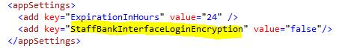

In the StaffBank client, In the Organisational Details screen a new tab titled StaffBank Interface Key setup has been created.

17 | P a g e
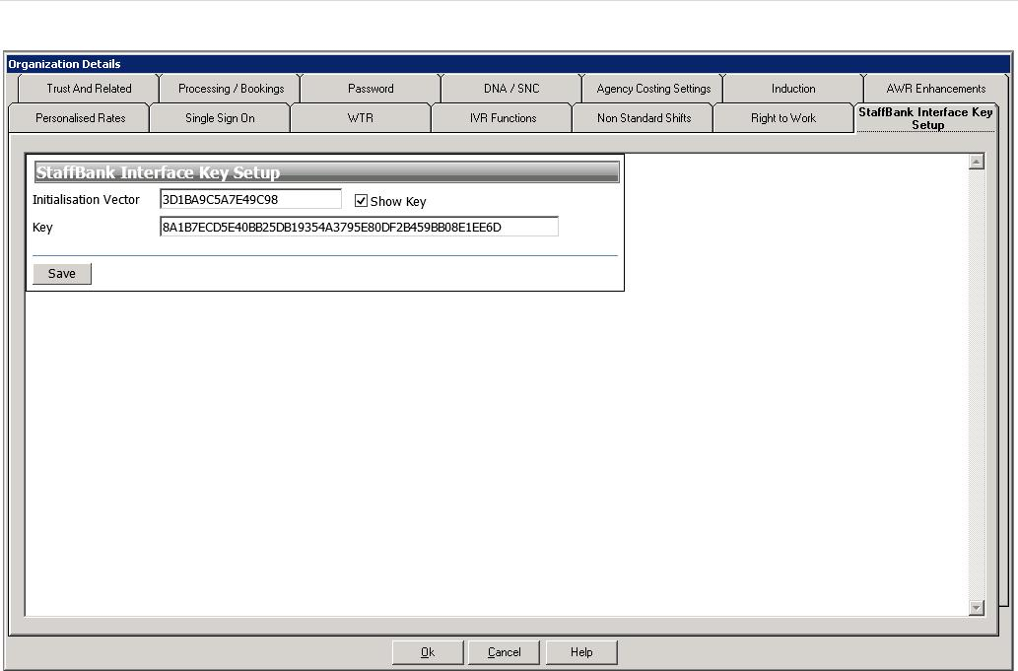

Please enter values into both the Initialisation vector as well as in the key fields. Both these fields accept hexadecimal values which allow numbers between 0-9 and alphabets between A-F.

Both the initialization vector and the key need to be shared with the 3rd party developer.

Encryption Code

Given below is the code snippet that the 3rd party developer will have to use to encrypt the user name and passwords for the AuthenticateCaller and AuthenticateFlexibleWorker methods,

using System;

using System.Security.Cryptography; using System.IO;

public class StaffBankInterfaceEncrypt
{

public byte[] encrypt(byte[] PlainText, byte[] key, byte[] iv)
{

TripleDESCryptoServiceProvider desEdeCipher = new TripleDESCryptoServiceProvider(); //Creates a symmetric encryptor object.

ICryptoTransform Encryptor = desEdeCipher.CreateEncryptor(key, iv); MemoryStream memoryStream = new MemoryStream();

//Defines a stream that links data streams to cryptographic transformations CryptoStream cryptoStream = new CryptoStream(memoryStream, Encryptor,

CryptoStreamMode.Write);

cryptoStream.Write(PlainText, 0, PlainText.Length); //Writes the final state and clears the buffer cryptoStream.FlushFinalBlock();

byte[] CipherBytes = memoryStream.ToArray(); memoryStream.Close();

cryptoStream.Close(); return CipherBytes;

}

18 | P a g e

}

Code Snippets

Creation of the Service Reference in Visual Studio.NET

Click on the project in the solution explorer to get the menu shown below
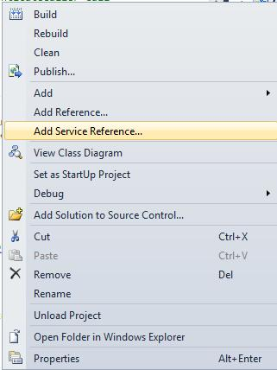

Select ‘Add Service Reference…’ from this menu.

In the dialog box that comes up enter the address of the StaffBank Interface WCF service. This is by default available at

http://[Server]/StaffBankInterface/StaffBankInterface.svc

Replace the [Server] with the actual server where the interface is installed. Click on the Go Button.

Enter any valid value in the Namespace.
StaffBankInterface has been used for the code snippets example.

19 | P a g e
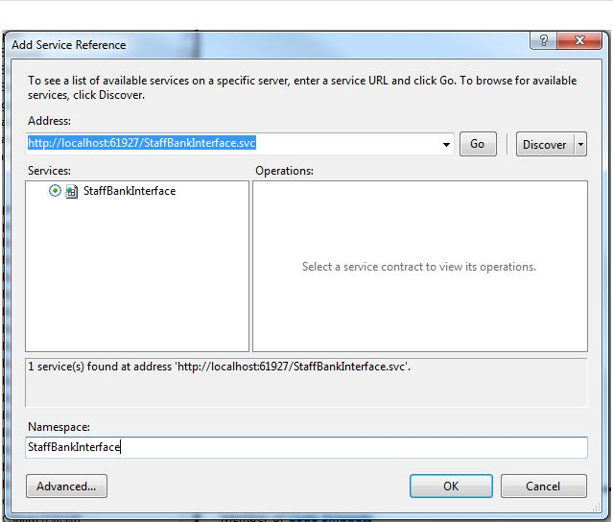

You should be able to see the service reference in the solution explorer.
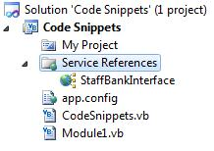
20 | P a g e

VB.NET Code Snippets

AuthenticateCaller

Public Sub AuthenticateCaller()
Dim iface As New StaffBankInterface.StaffBankInterfaceClient

'we need to pass the username and password given by NHSP to each 3rd party system 'Create the request

Dim request As New StaffBankInterface.AuthenticateCallerRequest

'Any positive integer can be passed. 'Ideally pass unique numbers for each request

'as they can be used for identifying request specially when trying to track issues request.RequestId = 1

'Any positive integer can be passed. request.UserName = "xxxxxxxx"

'This is the password provided by NHSP request.Password = "yyyyyyyy"

'Call the interface and obtain the response

Dim response As StaffBankInterface.AuthenticateCallerResponse response = iface.AuthenticateCaller(request)

If response.ErrorDescription = "" Then 'request has processed successfully

'This caller token has to be passed on all subsequent requests Dim callerToken As String = response.CallerToken

Else

'request has not been processed successfully End If

End Sub

21 | P a g e

AuthenticateFlexibleWorker

Public Sub AuthenticateFlexibleWorker()
Dim iface As New StaffBankInterface.StaffBankInterfaceClient

'Create the request
Dim request As New StaffBankInterface.AuthenticateFlexibleWorkerRequest

'Any positive integer can be passed. 'Ideally pass unique numbers for each request

'as they can be used for identifying request specially when trying to track issues request.RequestId = 1

'This is the caller token that is received in the AuthenticateCaller call request.CallerToken = "zzzzzzzz"

'This is the username of the flexible worker request.UserName = "aaaaaaaa"

'This is the username of the flexible worker request.Password = "bbbbbbbb"

'Call the interface and obtain the response

Dim response As StaffBankInterface.AuthenticateFlexibleWorkerResponse response = iface.AuthenticateFlexibleWorker(request)

If response.ErrorDescription = "" Then 'request has processed successfully

'True is the flexible worker is authenticated Dim canLogin As Boolean = response.CanLogin

'This is of the form Banknnnnn where nnnnn is the NurseId of the fw. Dim StaffId As String = response.StaffId

Else

'request has not been processed successfully End If
End Sub

22 | P a g e

CancelHolidayBooking

Public Sub CancelHolidayBooking()
Dim iface As New StaffBankInterface.StaffBankInterfaceClient

'Create the request
Dim request As New StaffBankInterface.CancelHolidayBookingRequest

'Any positive integer can be passed. 'Ideally pass unique numbers for each request

'as they can be used for identifying request specially when trying to track issues request.RequestId = 1

'This is the caller token that is received in the AuthenticateCaller call request.CallerToken = "zzzzzzzz"

'actual requester. This is the person against whom the change will be audited request.RequesterId = "sssssssss"

'This is the BookingReferenceNumber of the holiday booking to be cancelled request.BookingReferenceNumber = 999999

'call the interface and obtain the response

Dim response As StaffBankInterface.CancelHolidayBookingResponse response = iface.CancelHolidayBooking(request)

If response.ErrorDescription = "" Then 'request has processed successfully

'CancelHolidayBooking doesn't give any more details on the successful response Else

'request has not been processed successfully End If

End Sub

23 | P a g e

CreateHolidayBooking

Public Sub CreateHolidayBooking()
Dim iface As New StaffBankInterface.StaffBankInterfaceClient

'Create the request
Dim request As New StaffBankInterface.CreateHolidayBookingRequest

'Any positive integer can be passed. 'Ideally pass unique numbers for each request

'as they can be used for identifying request specially when trying to track issues request.RequestId = 1

'This is the caller token that is received in the AuthenticateCaller call request.CallerToken = "zzzzzzzz"

'actual requester. This is the person against whom the change will be audited request.RequesterId = "sssssssss"

'Shift Date of the Holiday Booking request.ShiftDate = CDate("12-Dec-2012")

'just sending the time itself can sometimes cause an issue 'so make sure it is at least min date

request.StartTime = Date.MinValue.Add(CDate("06:00").TimeOfDay) request.EndTime = Date.MinValue.Add(CDate("12:00").TimeOfDay)

'Rate at which this holiday booking is to be paid request.Rate = 99.9

'This is the StaffId of the flexible worker request.StaffId = "Banknnnnn"

'Call the interface and obtain the response

Dim response As StaffBankInterface.CreateHolidayBookingResponse response = iface.CreateHolidayBooking(request)

If response.ErrorDescription = "" Then 'request has been processed successfully

'Booking Reference Number of the holiday booking created

Dim bookingReferenceNumber As Integer = response.BookingReferenceNumber Else

'request has not been processed successfully End If

End Sub

24 | P a g e

ExactHolidayBooking

Public Sub ExactHolidayBooking()
Dim iface As New StaffBankInterface.StaffBankInterfaceClient

'Create the request
Dim request As New StaffBankInterface.ExactHolidayBookingRequest

'Any positive integer can be passed. 'Ideally pass unique numbers for each request

'as they can be used for identifying request specially when trying to track issues request.RequestId = 1

'This is the caller token that is received in the AuthenticateCaller call request.CallerToken = "zzzzzzzz"

'actual requester. This is the person against whom the change will be audited request.RequesterId = "sssssssss"

'Booking Reference Number of the Holiday Booking request.BookingReferenceNumber = 999999

'Call the interface and obtain the response

Dim response As StaffBankInterface.ExactHolidayBookingResponse response = iface.ExactHolidayBooking(request)

If response.ErrorDescription = "" Then 'request has processed successfully

Dim holidayBooking As StaffBankInterface.HolidayBooking holidayBooking = response.HolidayBooking

'get all the details from the holiday booking

Dim bookingReferenceNumber As Integer = holidayBooking.BookingReferenceNumber 'get all the other data from the holiday booking

'see details of HolidayBooking in the StaffBank Interface Reference Else

'request has not processed successfully End If

End Sub

25 | P a g e

GetFlexibleWorkerDetails

Public Sub GetFlexibleWorkerDetails()
Dim iface As New StaffBankInterface.StaffBankInterfaceClient

'Create the request
Dim request As New StaffBankInterface.GetFlexibleWorkerRequest

'Any positive integer can be passed. 'Ideally pass unique numbers for each request

'as they can be used for identifying request specially when trying to track issues request.RequestId = 1

'This is the caller token that is received in the AuthenticateCaller call request.CallerToken = "zzzzzzzz"

'StaffId of the flexible worker request.StaffId = "Banknnnnn"

'web user Id of the flexible worker

'either one of the staff id or the web user id is mandatory request.WebUserId = "kkkkkkkk"

'call the interface and obtain the response

Dim response As StaffBankInterface.GetFlexibleWorkerResponse response = iface.GetFlexibleWorkerDetails(request)

If response.ErrorDescription = "" Then 'request has processed successfully

Dim flexibleWorker As StaffBankInterface.FlexibleWorker = response.FW 'get details from the flexible worker

Dim surname As String = flexibleWorker.Surname 'get all the details from the flexible worker

'see details of FlexibleWorker in the StaffBank Interface Reference Else

'request has not processed successfully End If

End Sub

26 | P a g e

SearchFlexibleWorker

Public Sub SearchFlexibleWorker()
Dim iface As New StaffBankInterface.StaffBankInterfaceClient

'Create the request
Dim request As New StaffBankInterface.SearchFlexibleWorkerRequest

'Any positive integer can be passed. 'Ideally pass unique numbers for each request

'as they can be used for identifying request specially when trying to track issues request.RequestId = 1

'This is the caller token that is received in the AuthenticateCaller call request.CallerToken = "zzzzzzzz"

'call the interface and obtain the response

Dim response As New StaffBankInterface.SearchFlexibleWorkerResponse response = iface.SearchFlexibleWorker(request)

If response.ErrorDescription = "" Then 'response has processed successfully

Dim fws As StaffBankInterface.FlexibleWorker() = response.FlexibleWorkers For Each fw As StaffBankInterface.FlexibleWorker In fws

'get details of each fw returned on the search Dim surname As String = fw.Surname

'get all the details from the flexible worker

'see details of FlexibleWorker in the StaffBank Interface Reference Next

Else

'request has not processed successfully End If
End Sub

27 | P a g e

SearchHolidayBooking

Public Sub SearchHolidayBooking()
Dim iface As New StaffBankInterface.StaffBankInterfaceClient

'Create the request
Dim request As New StaffBankInterface.SearchHolidayBookingRequest

'Any positive integer can be passed. 'Ideally pass unique numbers for each request

'as they can be used for identifying request specially when trying to track issues request.RequestId = 1

'This is the caller token that is received in the AuthenticateCaller call request.CallerToken = "zzzzzzzz"

'actual requester. This is the person against whom the change will be audited request.RequesterId = "sssssssss"

'call the interface and obtain the response

Dim response As New StaffBankInterface.SearchHolidayBookingResponse response = iface.SearchHolidayBooking(request)

If response.ErrorDescription = "" Then 'response has processed successfully

Dim hols As StaffBankInterface.HolidayBooking() = response.HolidayBookings For Each hol As StaffBankInterface.HolidayBooking In hols

'get details of each holiday booking returned on the search

Dim bookingReferenceNumber As Integer = hol.BookingReferenceNumber 'get all the details from the holiday booking

'see details of HolidayBooking in the StaffBank Interface Reference Next

Else

'request has not processed successfully End If
End Sub

28 | P a g e

UpdateHolidayBooking

Public Sub UpdateHolidayBooking()
Dim iface As New StaffBankInterface.StaffBankInterfaceClient

'Create the request
Dim request As New StaffBankInterface.UpdateHolidayBookingRequest

'Any positive integer can be passed. 'Ideally pass unique numbers for each request

'as they can be used for identifying request specially when trying to track issues request.RequestId = 1

'This is the caller token that is received in the AuthenticateCaller call request.CallerToken = "zzzzzzzz"

'actual requester. This is the person against whom the change will be audited request.RequesterId = "sssssssss"

'Shift Date of the Holiday Booking request.ShiftDate = CDate("12-Dec-2012")

'just sending the time itself can sometimes cause an issue 'so make sure it is at least min date

request.StartTime = Date.MinValue.Add(CDate("06:00").TimeOfDay) request.EndTime = Date.MinValue.Add(CDate("12:00").TimeOfDay)

'Rate at which this holiday booking is to be paid request.Rate = 99.9

'This is the StaffId of the flexible worker request.StaffId = "Banknnnnn"

'call the interface and obtain the response

Dim response As New StaffBankInterface.UpdateHolidayBookingResponse response = iface.UpdateHolidayBooking(request)

If response.ErrorDescription = "" Then 'response has processed successfully

'There is no further details available on the UpdateHolidayBookingResponse Else

'request has not processed successfully End If
End Sub

29 | P a g e

C# Code Snippets

AuthenticateCaller

public void AuthenticateCaller()
{

StaffBankInterface.StaffBankInterfaceClient iface = new StaffBankInterface.StaffBankInterfaceClient;

//we need to pass the username and password given by NHSP to each 3rd party system //Create the request

StaffBankInterface.AuthenticateCallerRequest request = new StaffBankInterface.AuthenticateCallerRequest;

//Any positive integer can be passed. //Ideally pass unique numbers for each request

//as they can be used for identifying request specially when trying to track issues request.RequestId = 1;

//Any positive integer can be passed. request.UserName = "xxxxxxxx";

//This is the password provided by NHSP request.Password = "yyyyyyyy";

//Call the interface and obtain the response StaffBankInterface.AuthenticateCallerResponse response; response = iface.AuthenticateCaller(request);

if( response.ErrorDescription == "" )
{
//request has processed successfully

//This caller token has to be passed on all subsequent requests string callerToken = response.CallerToken;

}

else
{
//request has not been processed successfully
}

}

30 | P a g e

AuthenticateFlexibleWorker

public void AuthenticateFlexibleWorker()
{

StaffBankInterface.StaffBankInterfaceClient iface = new StaffBankInterface.StaffBankInterfaceClient;

//Create the request StaffBankInterface.AuthenticateFlexibleWorkerRequest request = new

StaffBankInterface.AuthenticateFlexibleWorkerRequest;

//Any positive integer can be passed. //Ideally pass unique numbers for each request

//as they can be used for identifying request specially when trying to track issues request.RequestId = 1;

//This is the caller token that is received in the AuthenticateCaller call request.CallerToken = "zzzzzzzz";

//This is the username of the flexible worker request.UserName = "aaaaaaaa";

//This is the username of the flexible worker request.Password = "bbbbbbbb";

//Call the interface and obtain the response StaffBankInterface.AuthenticateFlexibleWorkerResponse response; response = iface.AuthenticateFlexibleWorker(request);

if( response.ErrorDescription == "" )
{

//request has processed successfully

//True is the flexible worker is authenticated Boolean canLogin = response.CanLogin;

//This is of the form Banknnnnn where nnnnn is the NurseId of the fw. string StaffId = response.StaffId;

}
else
{
//request has not been processed successfully

}
}

31 | P a g e

CancelHolidayBooking

public void CancelHolidayBooking()
{

StaffBankInterface.StaffBankInterfaceClient iface = new StaffBankInterface.StaffBankInterfaceClient;

//Create the request StaffBankInterface.CancelHolidayBookingRequest request = new

StaffBankInterface.CancelHolidayBookingRequest;

//Any positive integer can be passed. //Ideally pass unique numbers for each request

//as they can be used for identifying request specially when trying to track issues request.RequestId = 1;

//This is the caller token that is received in the AuthenticateCaller call request.CallerToken = "zzzzzzzz";

//actual requester. This is the person against whom the change will be audited request.RequesterId = "sssssssss";

//This is the BookingReferenceNumber of the holiday booking to be cancelled request.BookingReferenceNumber = 999999;

//call the interface and obtain the response StaffBankInterface.CancelHolidayBookingResponse response; response = iface.CancelHolidayBooking(request);

if( response.ErrorDescription == "" )
{
//request has processed successfully

//CancelHolidayBooking doesn't give any more details on the successful response
}
else
{
//request has not been processed successfully

}

}

32 | P a g e

CreateHolidayBooking

public void CreateHolidayBooking()
{

StaffBankInterface.StaffBankInterfaceClient iface = new StaffBankInterface.StaffBankInterfaceClient;

//Create the request StaffBankInterface.CreateHolidayBookingRequest request = new

StaffBankInterface.CreateHolidayBookingRequest;

//Any positive integer can be passed. //Ideally pass unique numbers for each request

//as they can be used for identifying request specially when trying to track issues request.RequestId = 1;

//This is the caller token that is received in the AuthenticateCaller call request.CallerToken = "zzzzzzzz";

//actual requester. This is the person against whom the change will be audited request.RequesterId = "sssssssss";

//Shift Date of the Holiday Booking request.ShiftDate = DateTime.Parse("12-Dec-2013");

//just sending the time itself can sometimes cause an issue //so make sure it is at least min date

request.StartTime = DateTime.MinValue.Add(DateTime.Parse("06:00").TimeOfDay) request.EndTime = DateTime.MinValue.Add(DateTime.Parse("12:00").TimeOfDay)

//Rate at which this holiday booking is to be paid request.Rate = 99.9;

//This is the StaffId of the flexible worker request.StaffId = "Banknnnnn";

//Call the interface and obtain the response StaffBankInterface.CreateHolidayBookingResponse response; response = iface.CreateHolidayBooking(request);

if( response.ErrorDescription == "" )
{
//request has been processed successfully

//Booking Reference Number of the holiday booking created Int32 bookingReferenceNumber = response.BookingReferenceNumber;

}
else
{
//request has not been processed successfully

}
}

33 | P a g e

ExactHolidayBooking

public void ExactHolidayBooking()
{

StaffBankInterface.StaffBankInterfaceClient iface = new StaffBankInterface.StaffBankInterfaceClient;

//Create the request StaffBankInterface.ExactHolidayBookingRequest request = new

StaffBankInterface.ExactHolidayBookingRequest;

//Any positive integer can be passed. //Ideally pass unique numbers for each request

//as they can be used for identifying request specially when trying to track issues request.RequestId = 1;

//This is the caller token that is received in the AuthenticateCaller call request.CallerToken = "zzzzzzzz";

//actual requester. This is the person against whom the change will be audited request.RequesterId = "sssssssss";

//Booking Reference Number of the Holiday Booking request.BookingReferenceNumber = 999999;

//Call the interface and obtain the response StaffBankInterface.ExactHolidayBookingResponse response; response = iface.ExactHolidayBooking(request);

if ( response.ErrorDescription == "" )
{
//request has processed successfully

StaffBankInterface.HolidayBooking holidayBooking; holidayBooking = response.HolidayBooking;

//get all the details from the holiday booking

Int32 bookingReferenceNumber = holidayBooking.BookingReferenceNumber; //get all the other data from the holiday booking

//see details of HolidayBooking in the StaffBank Interface Reference
}
else
{
//request has not processed successfully

}
}

34 | P a g e

GetFlexibleWorkerDetails

public void GetFlexibleWorkerDetails()
{

StaffBankInterface.StaffBankInterfaceClient iface = new StaffBankInterface.StaffBankInterfaceClient;

//Create the request StaffBankInterface.GetFlexibleWorkerRequest request = new

StaffBankInterface.GetFlexibleWorkerRequest;

//Any positive integer can be passed. //Ideally pass unique numbers for each request

//as they can be used for identifying request specially when trying to track issues request.RequestId = 1;

//This is the caller token that is received in the AuthenticateCaller call request.CallerToken = "zzzzzzzz";

//StaffId of the flexible worker request.StaffId = "Banknnnnn";

//web user Id of the flexible worker

//either one of the staff id or the web user id is mandatory request.WebUserId = "kkkkkkkk";

//call the interface and obtain the response StaffBankInterface.GetFlexibleWorkerResponse response; response = iface.GetFlexibleWorkerDetails(request);

if( response.ErrorDescription == "" )
{

//request has processed successfully

StaffBankInterface.FlexibleWorker flexibleWorker = response.FW; //get details from the flexible worker

String surname = flexibleWorker.Surname; //get all the details from the flexible worker

//see details of FlexibleWorker in the StaffBank Interface Reference
}
else
{
//request has not processed successfully

}
}

35 | P a g e

SearchFlexibleWorker

public void SearchFlexibleWorker()
{

StaffBankInterface.StaffBankInterfaceClient iface = new StaffBankInterface.StaffBankInterfaceClient;

//Create the request StaffBankInterface.SearchFlexibleWorkerRequest request = new

StaffBankInterface.SearchFlexibleWorkerRequest;

//Any positive integer can be passed. //Ideally pass unique numbers for each request

//as they can be used for identifying request specially when trying to track issues request.RequestId = 1;

//This is the caller token that is received in the AuthenticateCaller call request.CallerToken = "zzzzzzzz";

//call the interface and obtain the response StaffBankInterface.SearchFlexibleWorkerResponse response; response = iface.SearchFlexibleWorker(request);

if ( response.ErrorDescription == "" )
{

//response has processed successfully

StaffBankInterface.FlexibleWorker[] fws = response.FlexibleWorkers; foreach( StaffBankInterface.FlexibleWorker fw in fws )

{

// get details of each fw returned on the search string surname = fw.Surname;

//get all the details from the flexible worker
//see details of FlexibleWorker in the StaffBank Interface Reference
}
}

else

{
//request has not processed successfully
}
}

36 | P a g e

SearchHolidayBooking

public void SearchHolidayBooking()
{

StaffBankInterface.StaffBankInterfaceClient iface = new StaffBankInterface.StaffBankInterfaceClient;

//Create the request StaffBankInterface.SearchHolidayBookingRequest request = new

StaffBankInterface.SearchHolidayBookingRequest;

//Any positive integer can be passed. //Ideally pass unique numbers for each request

//as they can be used for identifying request specially when trying to track issues request.RequestId = 1;

//This is the caller token that is received in the AuthenticateCaller call request.CallerToken = "zzzzzzzz";

//actual requester. This is the person against whom the change will be audited request.RequesterId = "sssssssss";

//call the interface and obtain the response StaffBankInterface.SearchHolidayBookingResponse response; response = iface.SearchHolidayBooking(request);

if ( response.ErrorDescription == "" )
{
//response has processed successfully

StaffBankInterface.HolidayBooking[] hols = response.HolidayBookings; foreach( StaffBankInterface.HolidayBooking hol in hols )

{

//get details of each holiday booking returned on the search Int32 bookingReferenceNumber = hol.BookingReferenceNumber; //get all the details from the holiday booking
//see details of HolidayBooking in the StaffBank Interface Reference

}

}
else
{
//request has not processed successfully
}

}

37 | P a g e

UpdateHolidayBooking

public void UpdateHolidayBooking()
{

StaffBankInterface.StaffBankInterfaceClient iface = new StaffBankInterface.StaffBankInterfaceClient;

//Create the request StaffBankInterface.UpdateHolidayBookingRequest request = new

StaffBankInterface.UpdateHolidayBookingRequest;

//Any positive integer can be passed. //Ideally pass unique numbers for each request

//as they can be used for identifying request specially when trying to track issues request.RequestId = 1;

//This is the caller token that is received in the AuthenticateCaller call request.CallerToken = "zzzzzzzz";

//actual requester. This is the person against whom the change will be audited request.RequesterId = "sssssssss";

//Shift Date of the Holiday Booking request.ShiftDate = DateTime.Parse ("12-Dec-2012");

//just sending the time itself can sometimes cause an issue //so make sure it is at least min date

request.StartTime = DateTime.MinValue.Add(DateTime.Parse("06:00").TimeOfDay); request.EndTime = DateTime.MinValue.Add(DateTime.Parse("12:00").TimeOfDay);

//Rate at which this holiday booking is to be paid request.Rate = 99.9;

//This is the StaffId of the flexible worker request.StaffId = "Banknnnnn";

//call the interface and obtain the response StaffBankInterface.UpdateHolidayBookingResponse response; response = iface.UpdateHolidayBooking(request);

if ( response.ErrorDescription == "" )
{
//response has processed successfully
//There is no further details available on the UpdateHolidayBookingResponse
}

else
{
//request has not processed successfully
}
}

38 | P a g e

StaffBank User Guide Changes

Version | Date | Change
1.02 | 25/07/2013 | ErrorCode added to the response
 |  | EngagementStatus added to the FlexibleWorker complex type
1.03 | 26/07/2013 | Code snippets in VB.NET added
1.04 | 29/07/2013 | Code snippets in C# added
1.05 | 30/08/2013 | Encryption of user name and password
 |  | Passing optional datetime values
1.06 | 01/10/2013 | Mapping of ShiftDate, StartTime and EndTime to Request fields added.
1.07 | 16/10/2013 | Mapping of ShiftDate, StartTime and EndTime added to the Reference
 |  | guide.

39 | P a g e

StaffBank Reference Changes

Version | Date | Change
1.02 | 25/07/2013 | ErrorCode added to the response
 |  | EngagementStatus added to the FlexibleWorker complex type
1.03 | 30/08/2013 | ExpiresOn added to the AuthenticateCallerResponse
1.04 | 16/10/2013 | Mapping of ShiftDate, StartTime and EndTime to Request fields added.

